IOT Theft Detection Using Raspberry Pi

Here we propose IOT based theft detection project using Raspberry Pi where we use image processing on live video to detect theft using motion and also highlight the area where motion occurred. This system secures offices/homes from theft by instantly detecting theft as well as allowing user to view the theft details thereby highlighting the theft details and saving the video in a usb drive. In this system we use a camera along with raspberry pi along with a circuit with LCD display IR for night vision and USB drive for storage. The system is powered y a 12V power supply. As soon as camera motion is detected in camera footage the system uses image processing to detect exact area of motion occurrence and highlights it accordingly. The system now transmits the images of the occurance over IOT to be viewed by user online. We here use IOT Gecko to develop the online system. Also it stores the footage in a USB drive for further reference. The user can now decode the data sent online using IOT Gecko IOT system to view the images of the motion occurance live remotely over internet. Thus the system provides an innovative approach to theft detection using IOT.

Block Diagram :
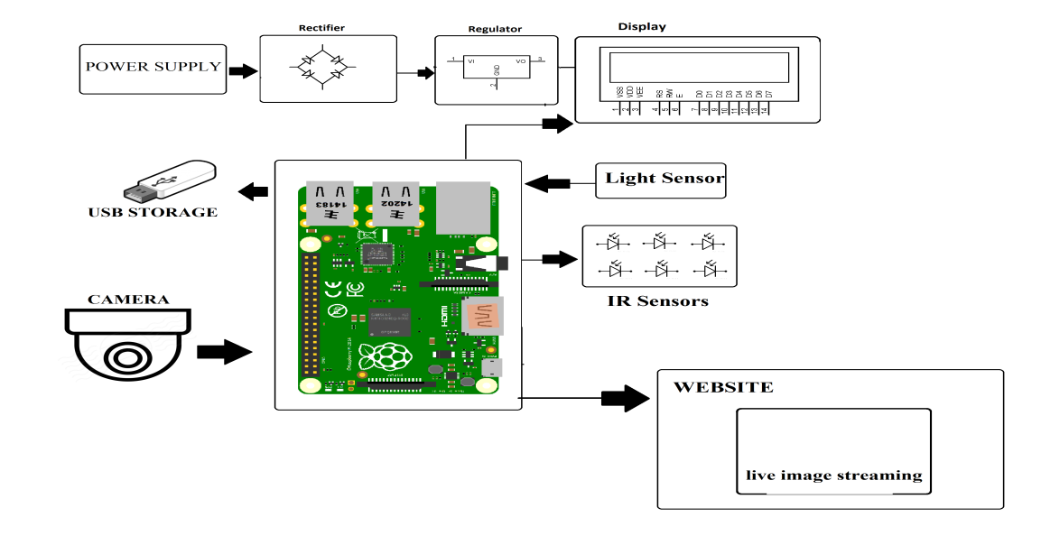

Hardware Specifications :
- Power Supply
- Rectifier
- Regulator
- LCD Display
- USB Drive
- IR LED’s
- USB Storage
- Camera
- Resistors
- Capacitors
- Diodes

Software Specifications :
- Linux OS
- Programming Language: Python
- IOTGecko

